Dr C Overton
Chairman SWAT
Mistletoe@btinternet.com

David Rowlands AC/AM
Chair Petitions Committee
National Assembly for Wales
Cardiff Bay
Cardiff
CF99 1NA

Dear Mr Rowlands

Re Petition P-05-768

I note the lateness, as usual, of Mr Moore’s response.

It is unfortunate that the Health Board seek to mislead and confuse us with their new approach to reporting the figures. It is also notable that the figures pre August 2014 have been lost when the whole point of the audit was to show how much worse the figures have become post service changes which happened at that time. Remaining at a similar level in recent years is no comfort when the figures were so much better prior to the changes.

No matter. I, no longer, can delve into the data entry, which I found during my audit was very poor with a number of occasions where the type of baby death was incorrectly recorded, and so it would be prudent of me to not waste your time repeating what I have already stated. It would require the committee to sanction an independent Inquiry to get to the truth about baby deaths in Hywel Dda, and Pembrokeshire in particular, and the comparison before and after the service changes.

Of much greater interest to me on reading the Hywel Dda documents was the data from “Dave”, the extra ambulance they employed originally to be dedicated, but which quite clearly from the report isn’t. Not only that but the use of “Dave” seems to be increasing, year on year. At first glance it appears to be the opposite but once I realised that year 3, the most recent, was put on top of 2 and 1 it made sense to me from the feeling on the ground. Why, you must ask, did they present the numbers in this way?

So, there we have it, the Health Board’s own statistics show that Pembrokeshire women and families have been and are being disadvantaged since the maternity, SCBU and Paediatric wards were moved to Glangwili. The large number of transfers is also just the tip of the iceberg as far as how these changes have impacted on women and their families because many more have had to travel to Glangwili under their own steam, sick children and mums in the back of cars being driven 33 miles or more by distraught relatives. Many visitors are also having to make the long round trip in order to provide support for their loved ones.

Hywel Dda had to carry out Equality Impact assessments on the run up to the service changes but the rules dictated that’s all they had to do, recognise the problems and strive to find solutions but there is no requirement that solutions are found. Hywel Dda recognised in their EqIAs that almost every person in Pembrokeshire would be disadvantaged by the service changes and to make matters worse they are currently considering further service change to the detriment of the people of Pembrokeshire.

On behalf of the SWAT Team and the people of Pembrokeshire I ask you to stop this madness and reverse the original service changes before any more damage is done. Centralisation works in cities but not in very rural areas.

Regards
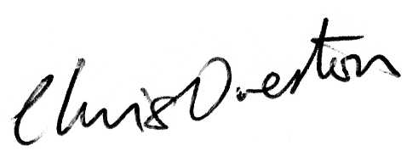
Dr Chris Overton
Chairman SWAT

